Retail Store Task Execution
UX Mockups and Interaction Specification
Document owner | Version | Date | Status
Michael Yaacoub, Sr Solution Engineer | 1.0 | 2026-08-24 | Draft

This template follows the sample UX pack: each SCR screen pairs a visual mockup with a specification panel, and the pack closes with a navigation-flow map.

1. Experience Overview
Three audiences share one record. A head office author targets and issues; a store colleague works the list on a shared handheld between serving customers, sometimes in a stockroom with no signal; a district manager watches the position across stores and steps in. Design principles: one list, ordered, so nobody has to decide what matters; state the proof requirement before the work rather than after; make the exception path as easy as the completion path, because a hidden blocker is worse than an incomplete task; and never let a store see another store's performance.
Persona | Primary goal | Device / viewport | Usage context
Store colleague | Know what to do next and prove it was done, between serving customers | Shared store handheld, 6 inch | Shop floor and stockroom, frequently interrupted, chilled areas, intermittent signal
District manager | See where execution stands across stores and intervene before the deadline | Laptop, 1440 pixels and wider, and phone when travelling | Travelling between stores, often reviewing on the move

2. Screen Inventory
Screen ID | Screen name | Mapped feature | User goal | Primary action
SCR-01 | Task Issue and Targeting | FEAT-01 | Send the right task to the right stores | Issue the task
SCR-02 | Store Task List | FEAT-02 | Know what to do next | Start the task
SCR-03 | Completion and Proof Capture | FEAT-03 | Prove the work was done at the fixture | Complete the task
SCR-04 | Compliance and Follow-up | FEAT-04 | See where execution stands and act on it | Raise a follow-up

3. Screen Mockups and Specifications

3.1 SCR-01 Task Issue and Targeting
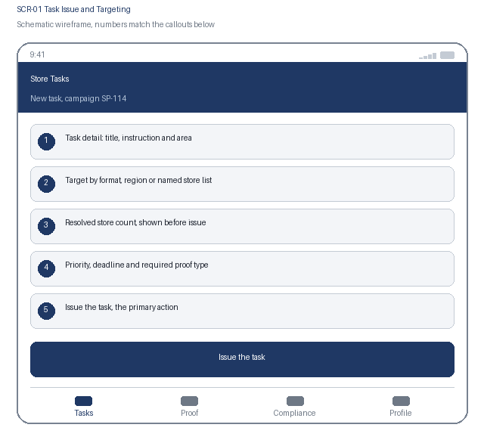  1. Task detail: title, instruction and area  2. Target by format, region or named store list  3. Resolved store count, shown before issue  4. Priority, deadline and required proof type  5. Issue the task, the primary action | Specification panel  Purpose: A head office author defines the task once, sees exactly which stores it will reach, and sets the expectations that make completion mean the same thing everywhere.  Primary action: Issue the task, which publishes it to every resolved store with its deadline and proof requirement.  Data: Task title, instruction, store area, target rule, resolved store list and count, priority, deadline, proof type and any reference image. Source: task service over the retail estate hierarchy.  States: Draft, targeting resolved, targeting incomplete and blocked, issued, partially delivered  Roles: Head office authors issue; district and regional managers read; stores see only their own copy  Requirements: US-101, US-102, NFR-002, NFR-007

3.2 SCR-01 Interaction Details
Element / callout | Behavior | Validation | Accessibility
1. Target selector | Selecting a format, region or store list resolves the count immediately | Targeting that cannot resolve fully blocks issue, and the reason is stated rather than issuing to a partial list | The resolved count is announced through a polite live region as it changes
2. Proof type selector | Choosing a proof type reveals its specific settings, such as a reference image or an expected count | A proof type is mandatory; photographic proof requires a reference image before issue | Radio group with a visible legend; revealed settings follow in DOM order and are announced
3. Deadline field | Sets the date and time by which stores must complete, in each store's local time | A deadline in the past is rejected; a deadline under 24 hours requires confirmation | Date and time inputs with visible labels and the local-time behaviour stated before the field
4. Issue the task | Publishes to every resolved store and starts the deadline clock | Blocked while targeting is unresolved or a proof requirement is incomplete, with each blocker listed | Confirmation states the store count and the deadline in plain words before issue

3.3 SCR-02 Store Task List
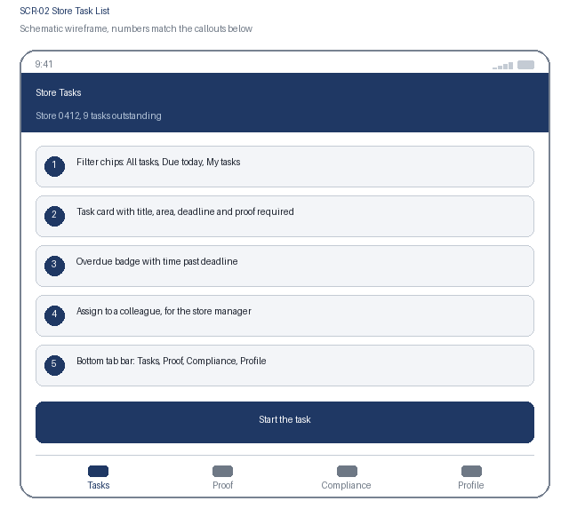  1. Filter chips: All tasks, Due today, My tasks  2. Task card with title, area, deadline and proof required  3. Overdue badge with time past deadline  4. Assign to a colleague, for the store manager  5. Bottom tab bar: Tasks, Proof, Compliance, Profile | Specification panel  Purpose: The colleague sees one ordered list of everything outstanding for this store and can start the next task without asking anyone.  Primary action: Start the task, which opens the instruction and the completion screen.  Data: Task title, store area, deadline in local time, priority, proof required, assignment state and assignee. Source: task service, scoped to this store only.  States: Loading, outstanding, due today, overdue, assigned, blocked by exception, offline  Roles: Store colleagues see their own store; store manager assigns; no cross-store visibility  Requirements: US-201, US-202, NFR-001, NFR-003, NFR-004

3.4 SCR-02 Interaction Details
Element / callout | Behavior | Validation | Accessibility
1. Filter chip | Filters in place and keeps scroll position; one chip active at a time | An empty result names the active filter and offers a route back to All tasks | Radio buttons in a labelled group with the selected state announced
2. Task card | Opens the task instruction and completion screen | None | One link whose accessible name combines the task title, area and deadline
3. Overdue badge | Shows time past the deadline; an overdue task stays actionable | An overdue task can still be completed, and lateness is recorded rather than blocking the work | Overdue state is stated as text with elapsed time, never by colour alone
4. Assign action | Opens a colleague picker for the store manager only | Assignment to a colleague not on shift prompts confirmation and returns the task to the pool at shift end | Combo box with an announced result count and keyboard-selectable options

3.5 SCR-03 Completion and Proof Capture
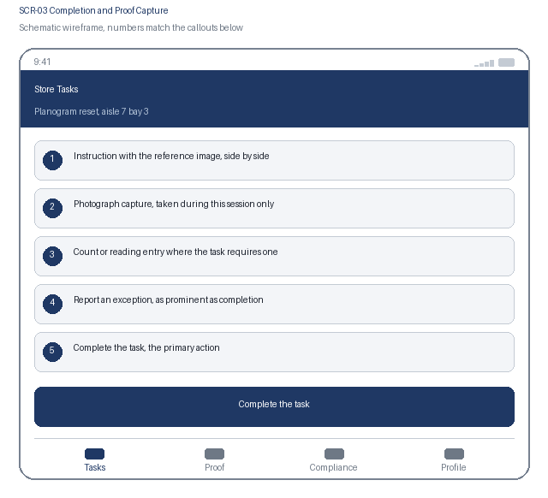  1. Instruction with the reference image, side by side  2. Photograph capture, taken during this session only  3. Count or reading entry where the task requires one  4. Report an exception, as prominent as completion  5. Complete the task, the primary action | Specification panel  Purpose: The colleague completes the work at the fixture and captures the proof there, or reports plainly that it cannot be done and why.  Primary action: Complete the task, which records the completion, the colleague and the proof.  Data: Instruction text, reference image, captured photographs with session identifier, captured count or reading, exception reason category and description. Source: task service.  States: In progress, proof captured, queued offline, completed, exception reported, upload pending  Roles: Any store colleague may complete; the completing colleague is recorded by name  Requirements: US-301, US-302, NFR-003, NFR-004, NFR-006

3.6 SCR-03 Interaction Details
Element / callout | Behavior | Validation | Accessibility
1. Reference comparison | Shows the reference image beside the captured photograph for side-by-side checking | None | Both images carry descriptive alternative text; the comparison is available in a single column on small screens
2. Photograph capture | Opens the camera; gallery selection is not offered because proof must be captured live | At least one photograph is required; the live-capture requirement is stated before the button rather than after an attempt | The camera-only requirement is announced, and an assisted-capture path is offered for colleagues who need it
3. Count or reading entry | Numeric entry shown only when the task requires a value | Must be within the expected range for the task; a value outside it requires a short note | Visible label, numeric keyboard hint, assertive error naming the field and the range
4. Report an exception | Opens the exception path with a reason category and description | Reason category and at least 15 characters of description are mandatory; the district manager is notified on submission | The exception action sits beside completion with equal prominence, so reporting a blocker is never the harder path

3.7 SCR-04 Compliance and Follow-up
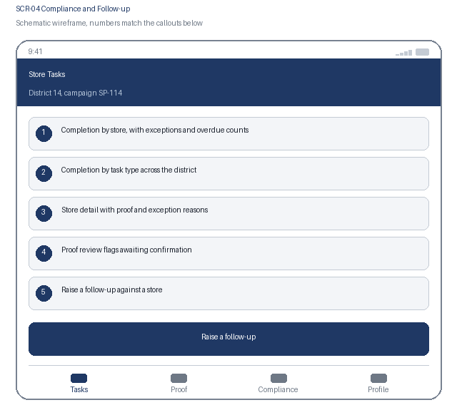  1. Completion by store, with exceptions and overdue counts  2. Completion by task type across the district  3. Store detail with proof and exception reasons  4. Proof review flags awaiting confirmation  5. Raise a follow-up against a store | Specification panel  Purpose: The district manager sees the live position across stores, opens the proof where it matters, and starts a recorded conversation instead of a phone call.  Primary action: Raise a follow-up, which attaches a recorded request to the task and notifies the store.  Data: Completion, exception and overdue counts by store and task type, task detail with proof photographs and exception reasons, proof review flags, follow-up state. Source: compliance aggregator, refreshed within 5 minutes.  States: Loading, current, refreshing, flagged proof awaiting review, follow-up open, follow-up closed  Roles: District and regional managers see their own stores; head office sees all; stores see only follow-ups raised against them  Requirements: US-401, US-402, NFR-001, NFR-004, NFR-006

3.8 SCR-04 Interaction Details
Element / callout | Behavior | Validation | Accessibility
1. Store row | Expands to show every task for that store with its state and proof | None | Disclosure with expanded state announced; completion figures stated as text with counts
2. Proof thumbnail | Opens the captured photograph beside the reference image | None | Each image carries alternative text describing the task and the capture time
3. Proof review flag | Shows an advisory mismatch flag awaiting the manager's confirmation | A flag never changes the compliance figure until the manager confirms it | The advisory nature is stated in text so an unconfirmed flag is never read as a failure
4. Raise a follow-up | Attaches a recorded request to the task and notifies the store | A message of at least 20 characters is mandatory; the follow-up cannot be closed without a store response | Focus moves to the message field with the requirement stated before entry

4. Navigation Flow
From | User action / condition | To | Alternate or error path
SCR-01 | Head office issues a targeted task | SCR-02, in every resolved store | Targeting unresolved: issue is blocked and the task stays in draft
SCR-02 | Colleague starts a task | SCR-03 | Task already completed by a colleague: the card refreshes and names who completed it
SCR-03 | Colleague completes the task with proof, or reports an exception | SCR-04, where the district position updates within 5 minutes | Offline: the completion and photographs queue locally and upload on reconnection
SCR-04 | District manager raises a follow-up | SCR-02, where the store sees the follow-up on the task | No response from the store: the follow-up stays open and is escalated to the regional manager
Flow: SCR-01 Task Issue and Targeting at head office, issue, to SCR-02 Store Task List, start a task, to SCR-03 Completion and Proof Capture, complete or report an exception, to SCR-04 Compliance and Follow-up for the district manager, and back to SCR-02 when a follow-up is raised. The bottom tab bar reaches Tasks, Proof, Compliance and Profile.

5. Responsive Behavior
Viewport | Navigation | Layout | Content priority | Interaction changes
Phone | Bottom tab bar with four primary destinations | Single column, cards stacked in priority order | Deadline, task title and proof requirement first; instruction detail below | One-handed reach with the camera action in the lower third; no swipe-only path to an action
Tablet | Adaptive left navigation rail | Task list beside the selected task's instruction and proof | Primary list beside the selected item's detail panel | Touch and pointer both supported; hover reveals nothing essential
Web | Persistent left navigation with breadcrumbs | Store grid, task detail and proof gallery in three columns | Dense scanning of many records, with full detail on selection | Full keyboard support with shortcuts for follow-up and proof review; no hover-only affordance

6. States and Content
State | Trigger | Displayed content | Available actions
Loading | A data request is still in flight after 300 ms | Skeleton cards preserving the final layout; the compliance view shows its refresh time | Cancel and retry remain available
Empty | A filter, search or assignment returns no records | A plain statement that no tasks match, naming the active filter | Clear the filter, or switch to All tasks
Error | A request fails, times out, or is rejected by policy | What failed and whether the completion and its photographs were kept | Retry, with the completion always preserved locally
Offline | The device loses network connectivity | A persistent offline banner and a count of completions waiting to upload | Completion and exception reporting continue; uploads confirm after reconnection

7. Accessibility Requirements
- WCAG 2.2 AA is the conformance target for every screen, including all interactive states and error messaging.
- Every control is reachable in a logical tab order with a visible focus indicator, a programmatic label, and instructions announced before the input rather than only after an error.
- Errors are announced through an assertive live region, name the field, and describe how to correct the problem.
- Text contrast is at least 4.5 to 1 and non-text indicators at least 3 to 1; the interface remains usable at 200 percent text resize and at 320 CSS pixels wide.
- Motion is limited and honours the reduced-motion preference; no information is conveyed by colour alone.
- Touch targets are at least 44 by 44 CSS pixels with adequate spacing, so the interface stays usable with gloves or one hand.
- {Keyboard order, visible focus, labels, instructions, and error announcement behavior}
- {Contrast, text resize, reduced motion, screen-reader, and touch-target expectations}

8. Review and Approval
Reviewer | Role | Decision | Comments | Date
Design lead | UX design authority | Pending | Interaction model and visual specification
Accessibility specialist | Accessibility | Pending | WCAG 2.2 AA conformance evidence
Product owner | Business product owner | Pending | Screen inventory and flow confirmation

